How to install driver for Tenda U2 adapter？
Model：U2 Free driver question category: internet setup
Steps are as follows:
1.Insert wireless network card in the USB port of your computer.
2.Install the network card driver automatically and restart your computer.
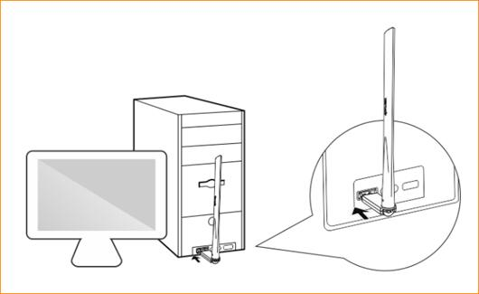
Please put the antenna up as far as possible

1、After the network card inserted into the computer, it will pop up the dialog box to install the driver and click the “Run AutoInst.exe” in the dialog box.
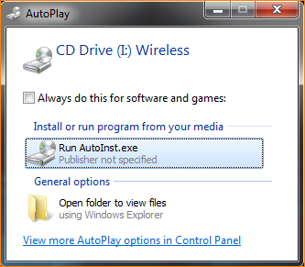
2、Wait for the progress bar to 100% of the installation page disappears, the lower right corner of the computer prompts the driver after the installation is complete (below), that is, on behalf of the driver installation is complete. After the driver installation is complete, you can connect to WiFi.
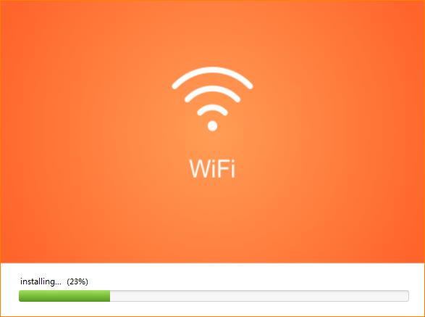
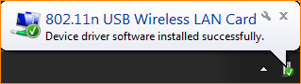
The lower right corner of the computer prompts the driver to complete the installation.

